**Max Marks:20 Time: 2 hours**

**Module-2: Lab Assessment (Infrastructure and Administration)**

**Attempt any 4 questions.**

1. Create ARM template and redeploy VM with the following changes.

VM Size: Standard_DS4_v2

Auto Shutdown: 5 PM UTC

Disk Type: Standard LRS

2. Create two windows based VMs in different VNETs as per below details and communicate between them using network peering.

VM1 name – puneetvm1quantiphi (replace name with your respective name)

VM2 name – puneetvm2quantiphi (replace name with your respective name)

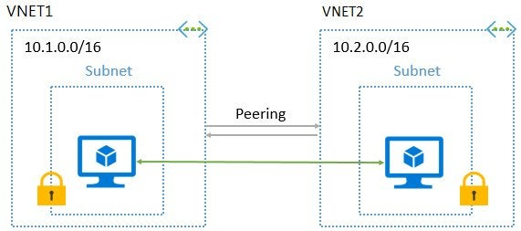

3. Configure an auto-scaling environment using VM scale set with 2 instances as default and initiate the scaling as per below rules.

Increase the number of instances by 1 if average CPU utilization > 50 %

Decrease the number of instances by 1 if average CPU utilization < 20 %

4. Setup a public Load Balancer with 2 Linux VMs with Apache installed on them and access the contents through web browser.

First VM home page content – “Welcome to Apache from VM1”

Second VM home page content – “Welcome to Apache from VM2”

5.What is Azure Bastion. Demonstrate a use case to establish remote connection with a VM using Bastion.